**HCMC UNIVERSITY OF TECHNOLOGY AND EDUCATION**

**FACULTY OF INFORMATION TECHNOLOGY**

**FINAL TERM PROJECT**

**Course name: Algorithms And Data Structures**

hotel management programs

**Lecturer name**: Assoc. Prof. Hoang Van Dung

**Group 7:**

Member: Nguyễn Đình Hồng Quân 19119045

Trần Phan Bảo Khang 19119059

Nguyễn Trọng Hải 19119028

*Ho Chi Minh City, 06/2022*

**HCMC UNIVERSITY OF TECHNOLOGY AND EDUCATION**

**FACULTY OF INFORMATION TECHNOLOGY**

**FINAL TERM PROJECT**

**Course name: Algorithms And Data Structures**

hotel management programs

**Lecturer name**: Assoc. Prof. Hoang Van Dung

Group 7:

Member: Nguyễn Đình Hồng Quân 19119045

Trần Phan Bảo Khang 19119059

Nguyễn Trọng Hải 19119028

*Ho Chi Minh City, 06/2022*

**STUDENT PROCESS**

|  |  |  |  |
| --- | --- | --- | --- |
| **ORDER** | **NAME** | **STUDENT ID** | **Contribution rate** |
| 1 | Nguyen Dinh Hong Quan | 19119045 | 100% |
| 2 | Tran Phan Bao Khang | 19119059 | 100% |
| 3 | Nguyen Trong Hai | 19119028 | 100% |

**Comment of Lecture:**

….………………………………………………………………………………………………………………………………………………………………………………………………………………………………………………………………………………………………………………………………………………………………………………………………………………………………………………………………………………………………………………………………………………………………………………………………………………………………………………………

….……………………………………………………………………………………………………………………………………………………………………………………………………………………………………………………………………………………………………………………………………………………………………….

Ho Chi Minh, day…..June, 2022

Score

(Sign and full name)

Hoang Van Dung

**Task assignment**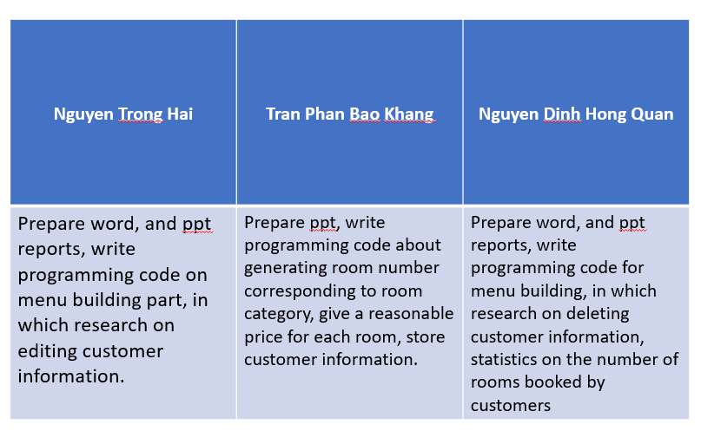

Acknowledgment

We would like to express our sincere thanks to Dung’teacher who guided us in the preparation of this report. He gave many ideas for us to grasp the problem of our report and besides, the presentation will be more effective. Our report has been successful thanks to Mr. Dung's guidance over the past three weeks.

However, due to many problems that arise as well as the time we do it, there are still many mistakes that are inevitable. We look forward to receiving all of your comments and suggestions to help our problems be answered and improved.

Sincerely thanks.

Preface

The purpose and objective of this course and mainly the content are to know data structure ( ex: Array, data type struct, class, Stack, Queue, tree...) and Algorithms( sort, search, add, modify, delete).

We have gained more confidence regarding coding and introducing products. We also believe that will make our group gain some kind of IT knowledge, and if we practice much and much will having some experiments in the future, then we will be able to survive smartly in today’s competitive environment.

The effort to write the report is a partial process to complete the course. In the report, we try to divide each of the topics into an individual chapter to reflect the topic more clearly.

Finally, we are very hopeful our topic of the report and code will be useful material for all the readers and users.

List of images

Figure 1. Block diagram 12

Figure 2. Header file 13

Figure 3. Public room 13

Figure 4. Pulic hotel 13

Figure 5. Struct room 13

Figure 6. Struct customer 14

Figure 7. Room information 14

Figure 8. Customer information 14

Figure 9. Add room 15

Figure 9.1.Information Standard Room 15

Figure 9.2.Information Moderate Room 15

Figure 9.3.Information Superior Room 16

Figure 9.4.Information Junior Room 16

Figure 9.5.Information Suite Room 16

Figure 10. Search Room 17

Figure 11. Delete Room 17

Figure 12. Check room_no 18

Figure 13. Check room_status 18

Figure 14. Set status 18

Figure 15. Check-in 19

Figure 16. Check-out 19

Figure 17. Get Available Room 20

Figure 18. Search customer 20

Figure 19. Guest summary report 21

Figure 20. Manage room 21

Figure 21. Menu 22

Figure 22. Test Menu 23

Figure 22.1. Test add room 23

Figure 22.2. Test search room 24

Figure 22.3.Test delete room 25

Figure 23. Test check-in room 26

Figure 24. Test available rooms 26

Figure 25. Test search customer by name 27

Figure 26. Test check-out 27

Figure 27. Test summary 28

Figure 28. Exit 28

CONTENT

Acknowledgment 5

Preface 6

List of images 7

1. Project description 9
2. Objectives 9
3. Scope and object 9
4. Theoretical basis 10
   * + 1. Dev-C++ 10
       2. C++ language 10
       3. Linked list 10
       4. Deployment method 10
5. Design 12
6. Block diagram 12
7. Process description 12
8. The project's main features 12
9. **Implementation of Hotel Management System 12**
10. Test Cases 23
11. Conclusion 29
12. Result 29
13. Difficulties and limitations 29
14. Development of ideas 29

References 30

1. Project description
2. Objectives

With the topic "Building a hotel management program", our main goal is to build a program to support effective hotel management and can be applied in practice, managing booking problems. room, edit information, check-out, room type, invoice.

The program has a simple interface, effective management, easy to use.

1. Scope and object

Project on building a hotel management system. That shows just based on the hotel's booking and payment management. Users can manage bookings and, customer profiles, view total allocated rooms, edit infor,mation, and make payments.

1. Theoretical basis
   * + 1. Dev-C++

Dev-C++ is a full-featured integrated development environment (IDE), which is able to create Windows or DOS-based C/C++ programs using the Mingw compiler system (included with the package), or the Cygwin compiler. These are the recommended requirements of Dev-C++:

+Microsoft Windows 98, NT or 2000

+32 MB RAM

+233 Mhz Intel-compatible CPU

+45 MB free disk space

Dev-C++ allows you to write, compile and run a C or C++ program. C++ programming language is an enhanced version of the C language that provides object-oriented programming (OOP) capabilities. It is a superset of C, which means that you can use a C++ compiler to compile C programs. Object-oriented programming techniques differ significantly from the sequential programming used in the C programming language. Although a C++ compiler like Dev-C++ allows you to compile a C program that includes some features of C++, in this course, we will concentrate on the C programming language. A program written in pure C language may be compiled and run using other C compilers, like Turbo C, etc.

* + - 1. C++ language

**C++** is a [high-level](https://www.britannica.com/dictionary/high-level) computer [programming language](https://www.britannica.com/technology/computer-programming-language). Developed by Bjarne Stroustrup of [Bell Laboratories](https://www.britannica.com/topic/Bell-Laboratories) in the early 1980s, it is based on the traditional [C](https://www.britannica.com/technology/C-computer-programming-language) language but with added [object-oriented programming](https://www.britannica.com/technology/object-oriented-programming) and other capabilities. C++, along with [Java](https://www.britannica.com/technology/Java-computer-programming-language), has become popular for developing commercial [software](https://www.britannica.com/technology/software) packages that incorporate multiple interrelated applications. Large parts of many operating systems are written in the language. C++ is considered one of the fastest languages and is very close to low-level languages, thus allowing complete control over memory allocation and management. This very feature and its many other [capabilities](https://www.britannica.com/dictionary/capabilities) also make it one of the most difficult languages to learn and handle on a large scale.

* + - 1. Linked List

A linked list is a data structure used to store a set of discrete elements that can be dynamically expanded.The size of the linked list does not need to be defined in advance, it automatically changes when the number of elements in the list changes.

+ Unlimited number of elements

+ Easy to perform operations: add, delete, edit

+ Sequential data retrieval

* + - 1. Deployment method

+ Learn about the room management mechanism

+Learn C++ programming language

+ Dev-C++ support tools

+ Analyze functions

+Database Design

+Writing Programs

+ Implement and evaluate the results

1. Design
2. Block diagram

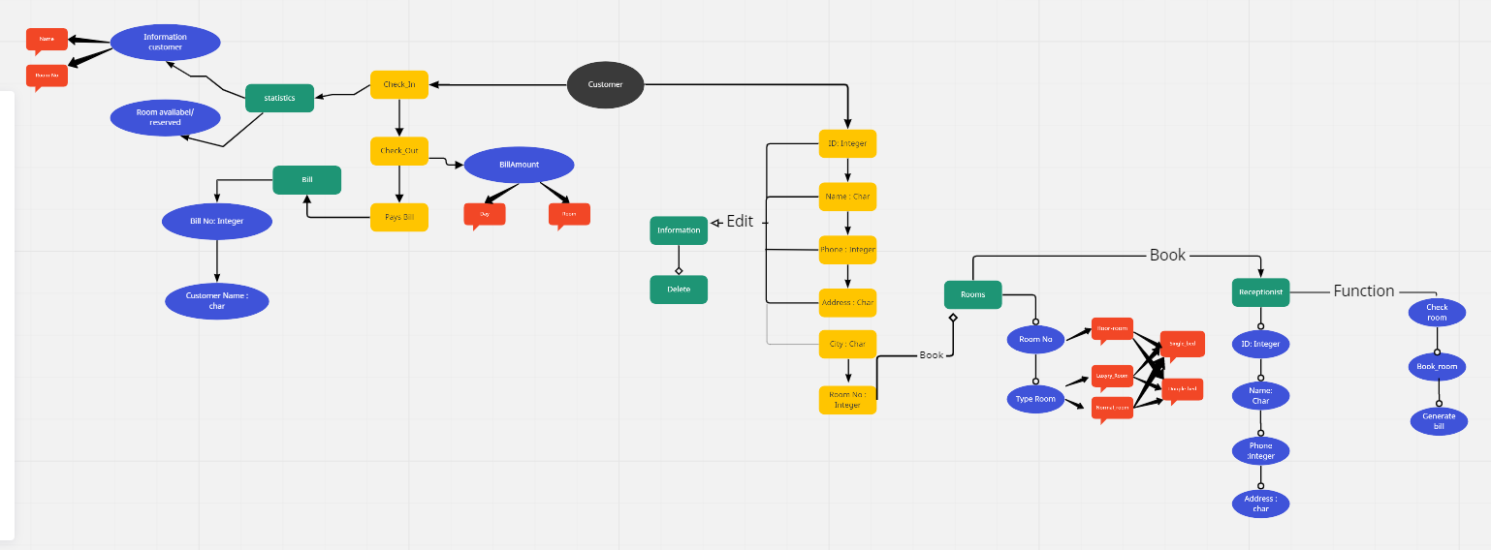

Figure 1.Block diagram

1. Process description

It includes class, object, array, function, loop, and structure in hotel management projects based on C++ language. When this code is launched, the user will see a menu with five options numbered from 1 to 5, then the program will execute the correct choice of the user to output the functions that match the content needed to capture information.

1. The project's main features

* Room management: In this project, we can manage and statistics the number of rooms that are available or booked.
* Guest Check-in and Check-out: Using this project, we can track guest check-in or check-out activity over time.
* Check-in availability: we make a list of available rooms
* Edit customer information: Adjust customer information when incorrect information is entered
* Searching for customers: Using this feature, we can search for any customer, what type of room is in and how many rooms are there
* Invoice printing: this feature helps to calculate the amount the customer needs to pay

1. **Implementation of Hotel Management System**

**Step1:** Create a new **Project**inDev C++



Step2: we will include all **header** **file** which will use in project



Figure 2.Header file

Step3 : Add the following line below **header** file:



**ROOM**

Step4: we will create a class(**room**) that can take the details of the room through a public

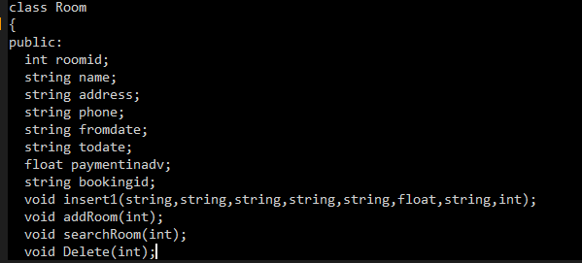

Figure 3.Public room

Step5: we will create a public which can take the details of the menu hotel.



Figure 4. Pulic hotel

Step6: we will create a struct which can take the details of the room

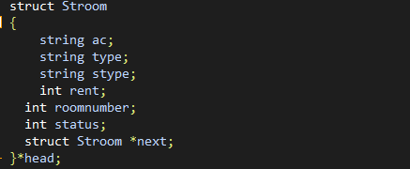

Figure 5. Struct room

Step7: we will create a struct which can take the details of the customer

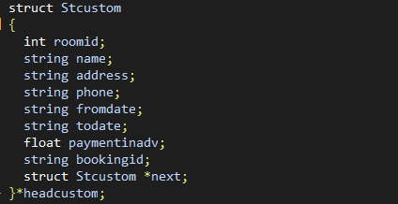

Figure 6. Struct customer

Step8: The insert function is to insert a node into the single list of Room

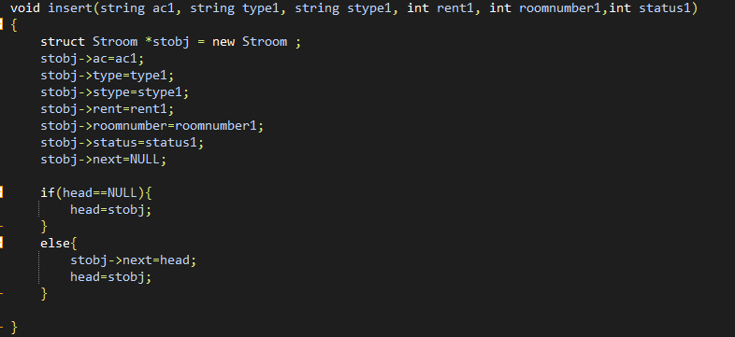

Figure 7.Room information

Step9: The insert 1 function is to insert a node into the customer's single list

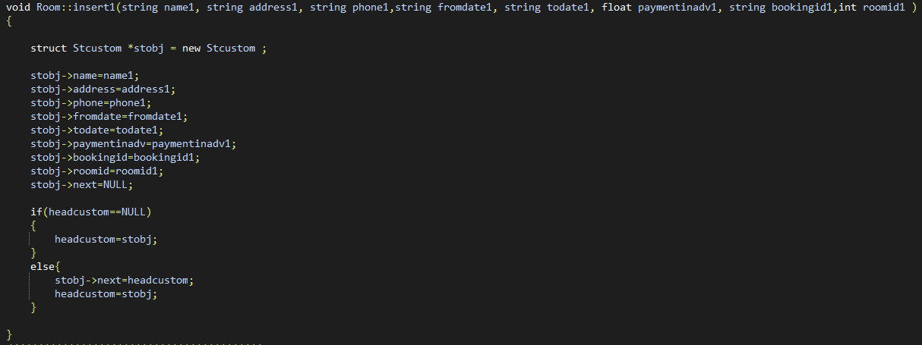

Figure 8. Customer information

Step 6 : Now we will create a function to **add, search, delete**

* **Add Room**

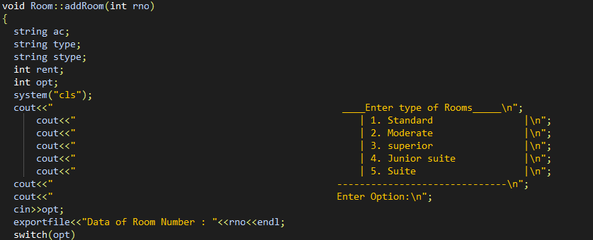

Figure 9. Add room

In function add room we have Room type, Comfort type, Type Size, Room Rent

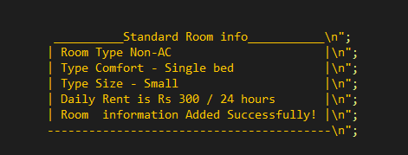

**Figure 9.1.Information Standard Room**

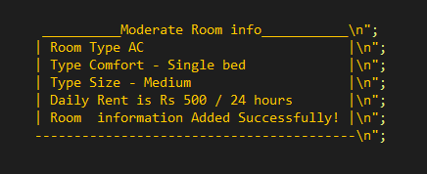

**Figure 9.2.Information Moderate Room**

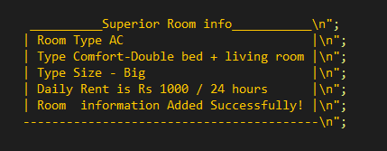

**Figure 9.3.Information Superior Room**

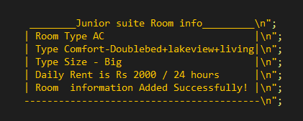

**Figure 9.4.Information Junior Room**

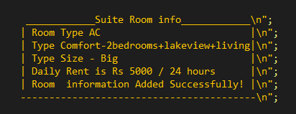

**Figure 9.5.Information Suite Room**

* **Search Room**

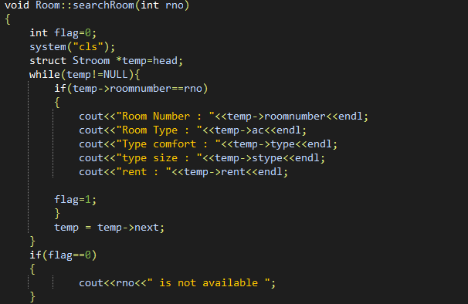

**Figure 10. Search Room**

* **Delete Room**

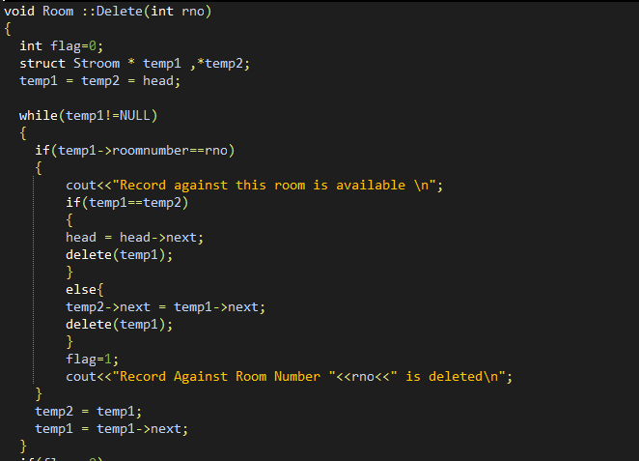

**Figure 11. Delete Room**

**Checkroom is to go through the single list to check if the room number is created in the single list. If yes, return true.**

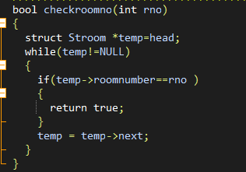

**Figure 12. Check room_no**

**Check Room Status is to check if the room number has been booked**

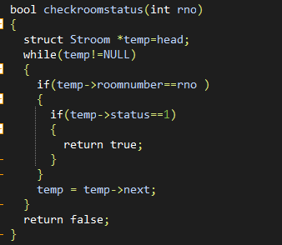

**Figure 13. Check room_status**

**Setstatus is to update the room number that is already booked**

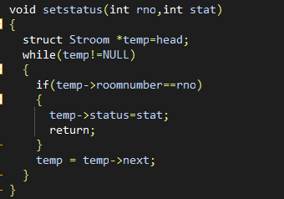

**Figure 14. Set status**

**HOTEL MANAGE**

**In hotel management we have function: a check-in, check out, get available, search for customer and guest summary, manage room.**

* **Check-in**

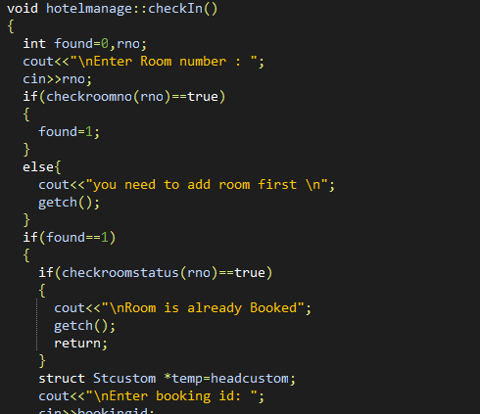

**Figure 15. Check-in**

* **Check-out**

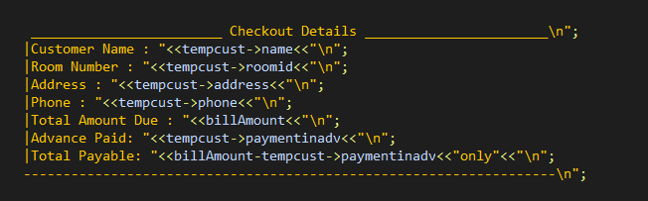

**Figure 16. Check-out**

* **Get available**

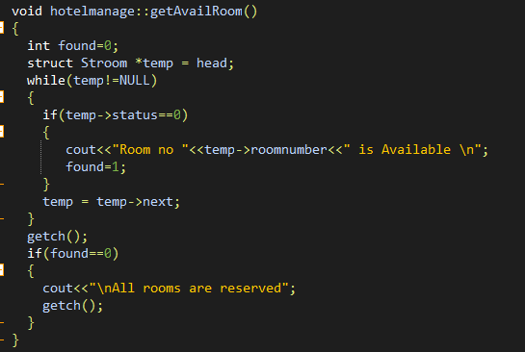

**Figure 17. Get Availble Room**

* **Search customer**

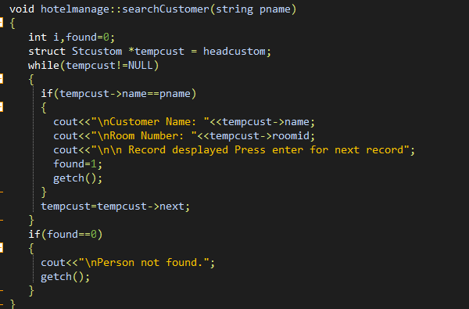

**Figure 18. Search Customer**

* **Guest summary**

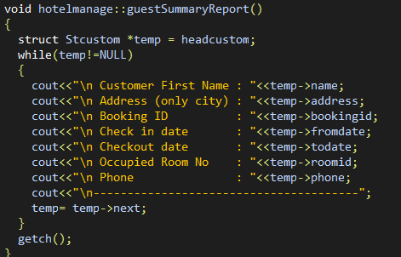

**Figure 19. Guest summary report**

* **Manage room**

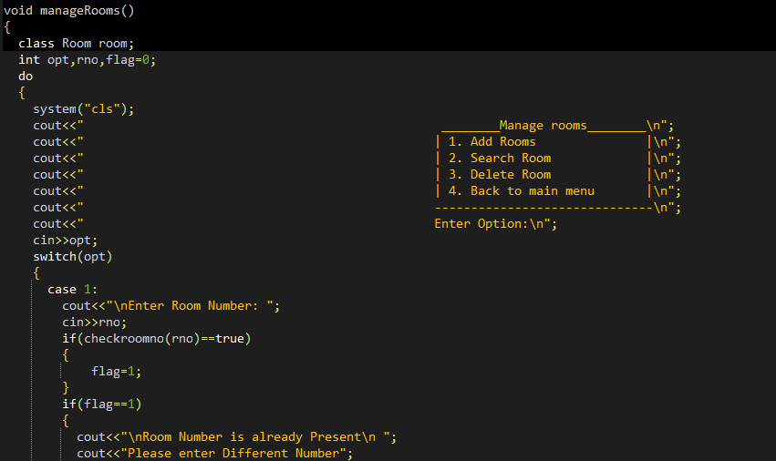

**Figure 20. Manage room**

**Final step is Menu**

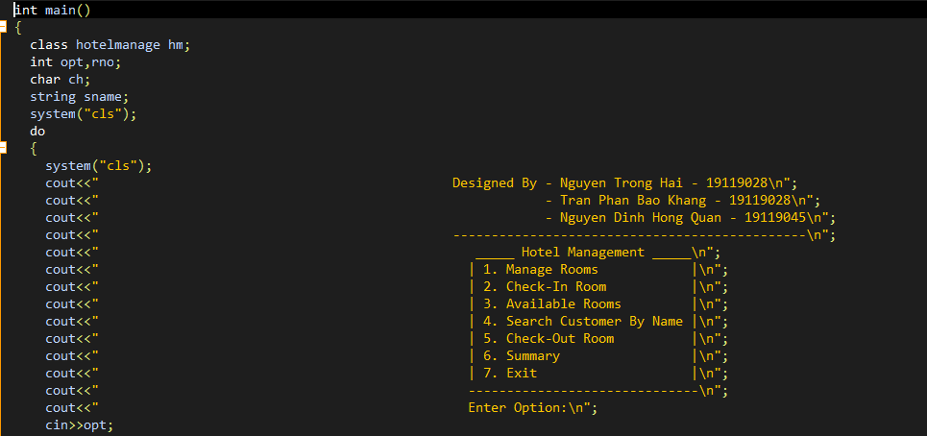

**Figure 21. Menu**

1. Test case

* Menu 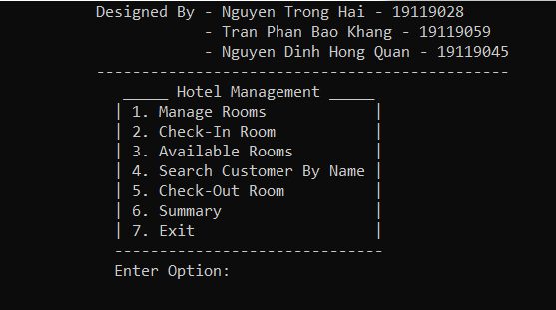

Figure 22.Test Menu

Case1 : Manage room

* Test Add room

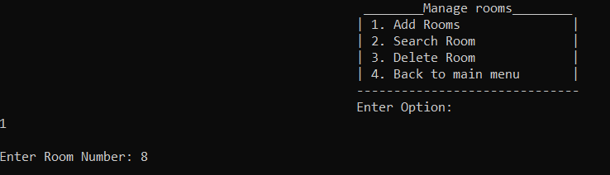 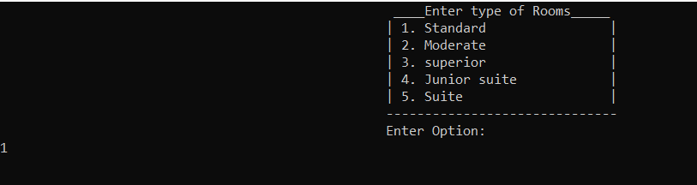

Figure 22.1. Test add room

After create room , it will show infomation of type of room

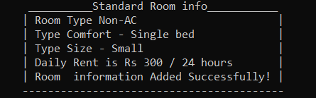

* Test Search Room

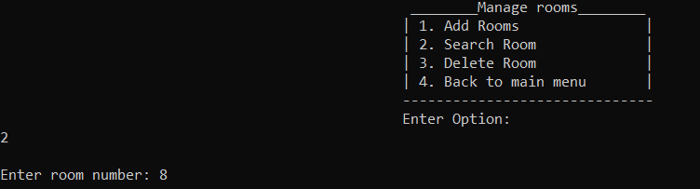

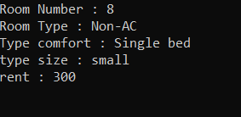

Figure 22.2. Test search room

If input room wrong it will show

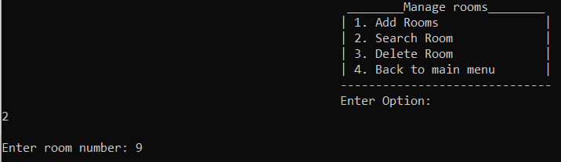 

* Test Delete Room

Delete Room is not available it will show text in figure below 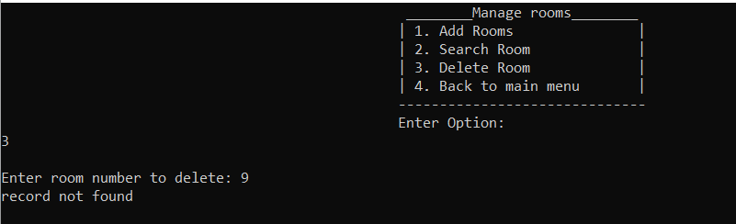

If input correct, it will delete 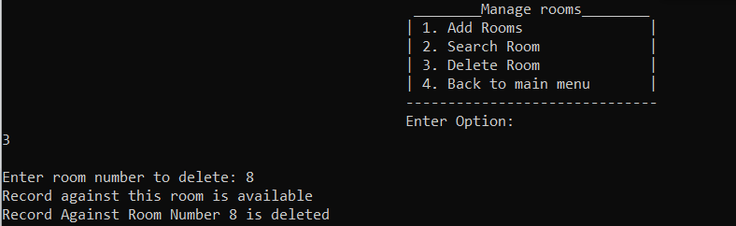

Figure 22.3.Test delete room

Case 2 : Check-in Room

Wrong Input , it will warning

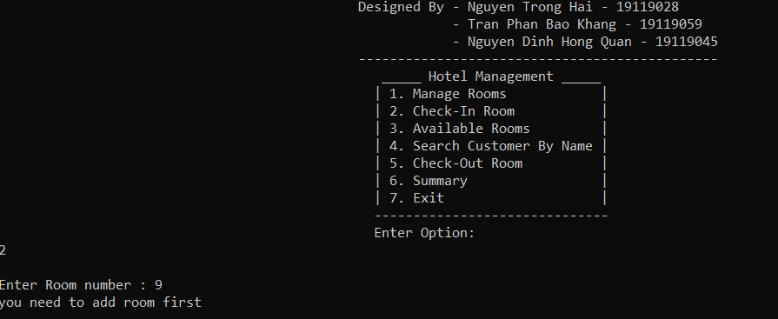

Right Input , we will fill information

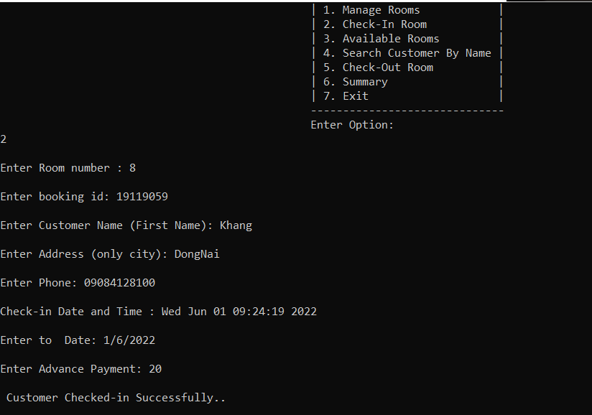

Figure 23.Test check-in room

Case 3 : Available Rooms

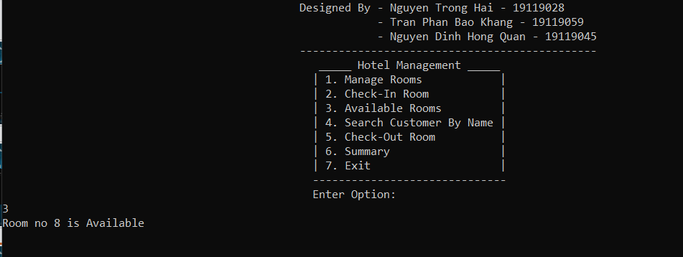

Figure 24. Test availble rooms

Case 4 : Search Customer By Name

Name record is valid

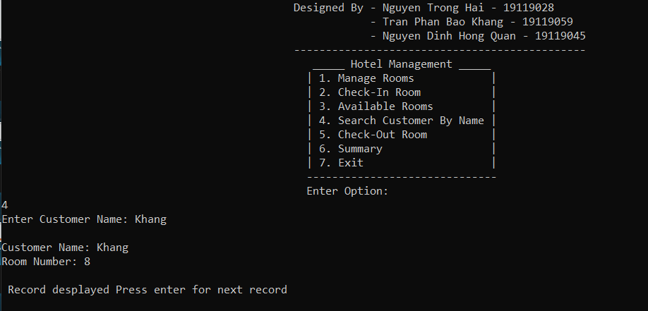

Name record is wrong

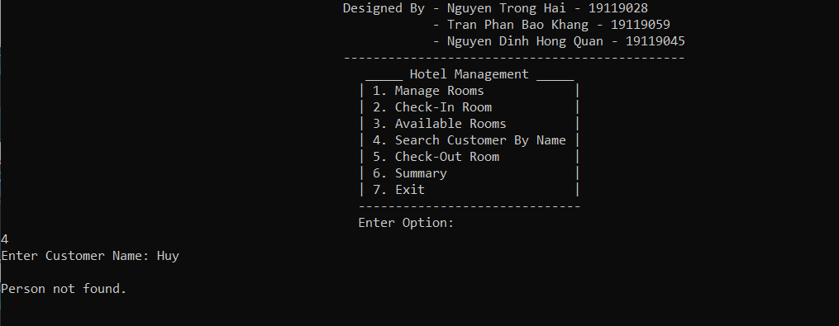

Figure 25. Test search customer by name

Case 5 : Check- out Rooms

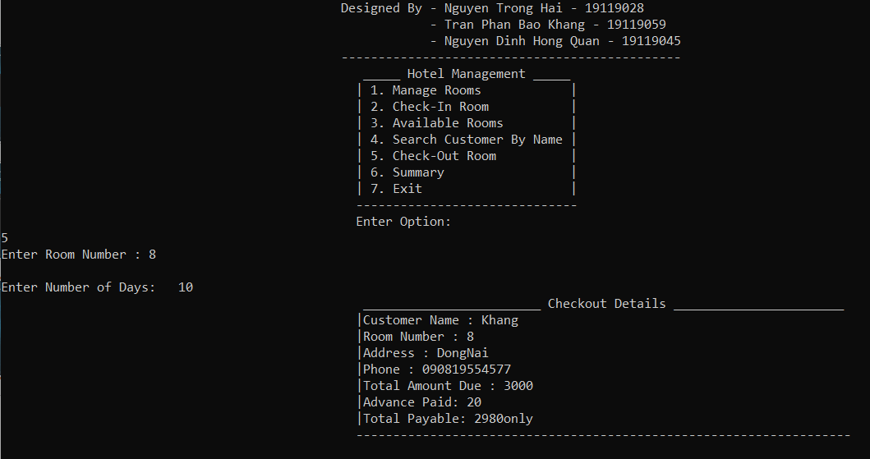

Figure 26. Test check-out

Case 6 : Summary

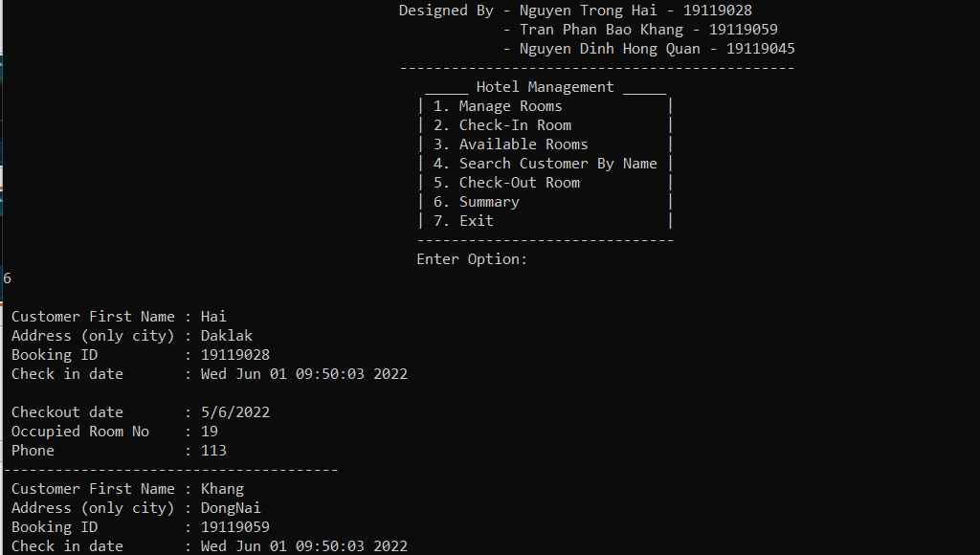

Figure 27. Test summary

Case 7 : Exit

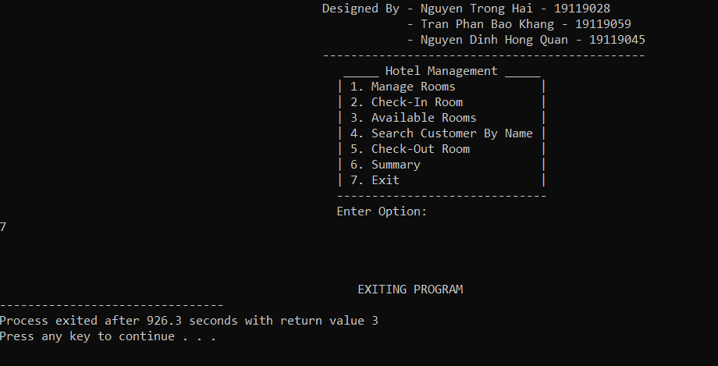

Figure 28. Exit

1. Conclusion
   * + 1. Result

Successfully implemented the construction of a hotel management system in C++ language, displaying information through the screen, selecting and implementing, implementing,….

* + - 1. Difficulties and limitations

Customer satisfaction has not been assessed yet

* + - 1. Development of ideas

Will do more management work such as assessing guest satisfaction, allowing to assess whether the service level of the hotel is good or not.

References

1. <https://www.academia.edu/43499326/Hotel_Management_Project_Using_C_OOP_structure>
2. <https://rrtutors.com/tutorials/hotel-management-system-project-using-c-plus-plus>
3. <https://www.cppbuzz.com/projects/c++/c++-project-on-hotel-management>

Link video nhóm :

<https://drive.google.com/drive/folders/1n1j8rhp9mpEiiDg262sOZ5zsMd02JBGX?usp=sharing>